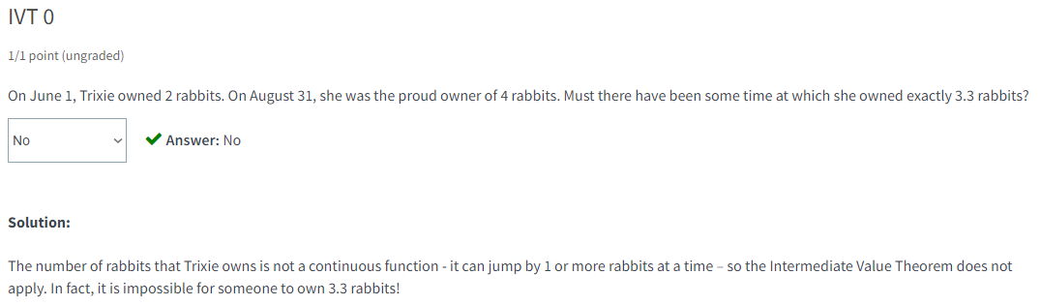

Using the IVT

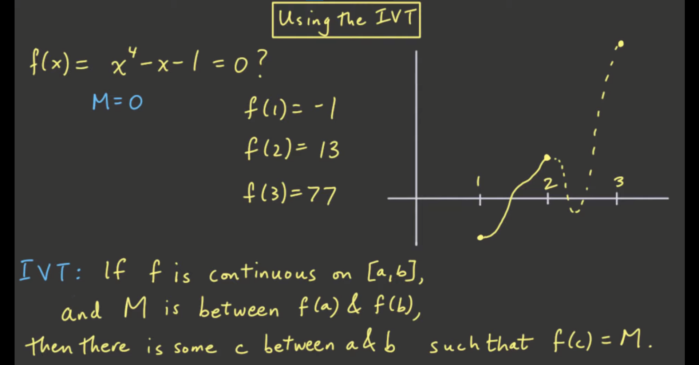

* There is definitely one root between f(1) and f(2)
* This is the application of IVT (something like conclusion that you can formulate by just looking at the functions and graph)
  + Even when you are not solving the exact answer
* This is like a question of “Is there a root between x = … and x = … ?”

Examples/Questions

